1. **Introduction**

Thank you for purchasing GOAL Template. The current documentation file is meant to provide you with the help you need to setup and customize your new newly purchased template.

1. **Installation**

This is an HTML5 Template, so setting up the template is a very easy task. All you have to do is to move the contents of the GOAL folder to your FTP account.

We suggest adjusting the contact form settings before uploading.

1. **Setup**

All you have to do is to setup the contact form setting by editing the *contact.php* file located in *GOAL/assets/php* folder with your personal information.

Go to **line 6** in contact.php and you’ll find this.

*$for = 'mail@example.com';*

Replace *mail@example.com* with your personal email and you’re done.

You can also change the subject message in **line 7** by replacing ‘*new message’* with your desired message.

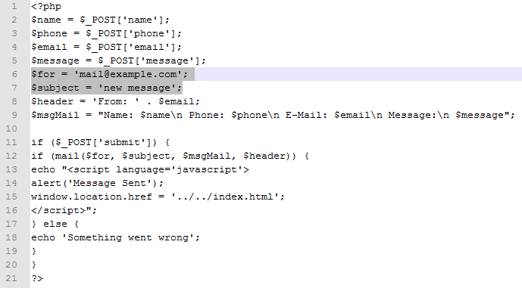

1. **The Grid**

This template was built using zurb foundation 4 Framework http://foundation.zurb.com, it is super easy to customize the layout and grids. Foundation offers a great grid system and here you will learn how to use the column grid properly so that your resume will look good no matter the resolution or device it is viewed on.

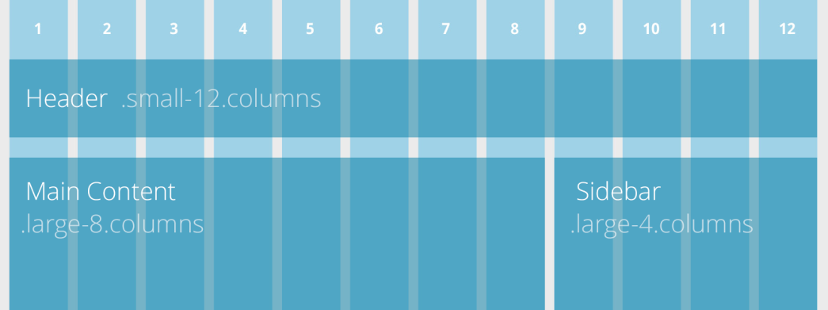

Create powerful multi-device layouts quickly and easily with the default 12-column, nest-able Foundation grid. If you're familiar with grid systems, you'll feel right at home. If not, you'll learn quickly.

Start by adding an element with a class of **row**. This will create a horizontal block to contain vertical columns. Then add divs with a **column** class within that row. You can use **column** or **columns** - the only difference is grammar. Specify the widths of each column with the **small-#** and **large-#** classes.

*Foundation is mobile-first. Code for small screens first and larger devices will inherit those styles. Customize for larger screens as necessary.*

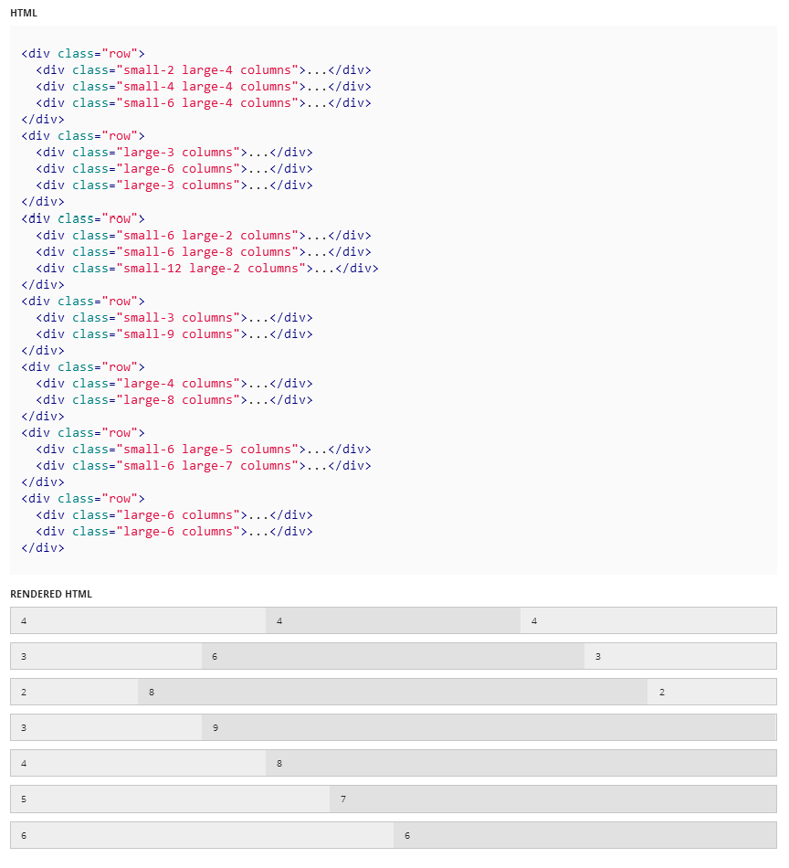

*For further documentation on the grid system and many other features please visit* [*http://foundation.zurb.com/docs/*](http://foundation.zurb.com/docs/)

1. **Sections**

By default, the resume consists of 7 sections, built around the column grid described above.

1. Intro / Menu
2. Services
3. The Team
4. Portfolio
5. Testimonials / Skills / Clients
6. Contact
7. Footer
   1. **Intro**

The **Intro** section contains the title and description of the website inside a fixed wrapper under the **fixed-title** class.

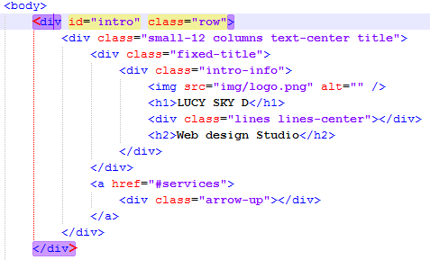

Below the **fixed-title** class you will find an ***a*** tag with an **arrow-up** class inside, this is the triangle button at the bottom of the **intro** section, which scrolls the rest of the page to the top.

**Menu**

The menu bar under the intro section transforms itself into a sticky bar when it reaches the top of the website. Each menu item is displayed as an icon with the following syntax.

<div class="icon-*Someicon*"></div>

You can check all available icons under the *documentation/icons/demo.html* file.

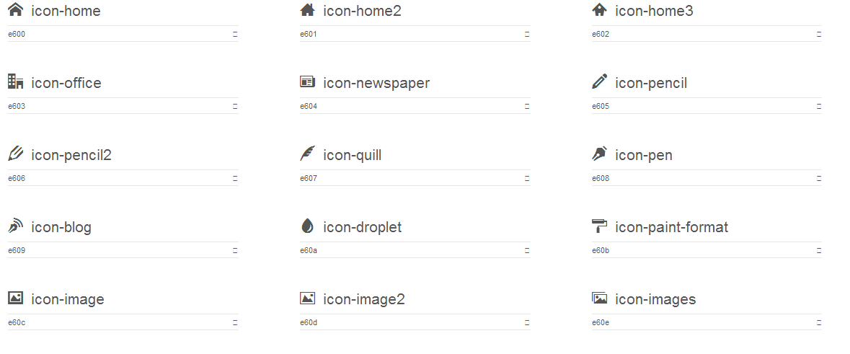

*And many more…*

*Notice the <span class= “****item-hide****”> tag inside the link?* ***On low resolutions****, the letters inside those tags* ***will be hidden****. This means that on mobile, only the first three letters of your buttons will show up.*

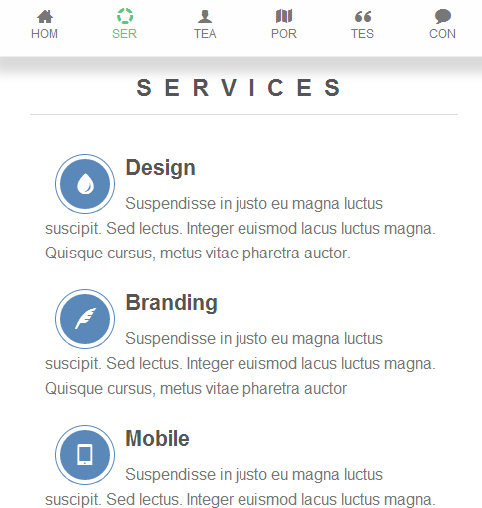

* 1. **Services**

The services section is displayed using the grid system explained above, so it is super easy to customize in case you want to. It is divided in 2 rows and each row in multiple columns. The second row has in it a completion rate chart, to customize it just change the data-percent value.

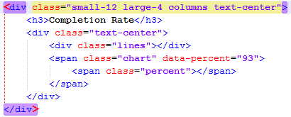

* + 1. **Board**

This is a simple board displaying a header, a sub-header and a button. It also has a rotating word script in order to make it fancier. To modify this rotating words please edit the assets/rotating-words.js file.



* 1. **The Team**

This is very easy to customize, each row has one or more columns which displays a picture of the teammate and some social links and other columns show a ribbon of the teammate activity. The picture has a reveal-mode feature provided by zurb foundation (http://foundation.zurb.com/docs/components/reveal.html), when you click on the picture.

* 1. **Portfolio**

The portfolio is shown using a very fancy slider (slit slider) and it is very easy to add new items to it. Each item is under this piece of code.

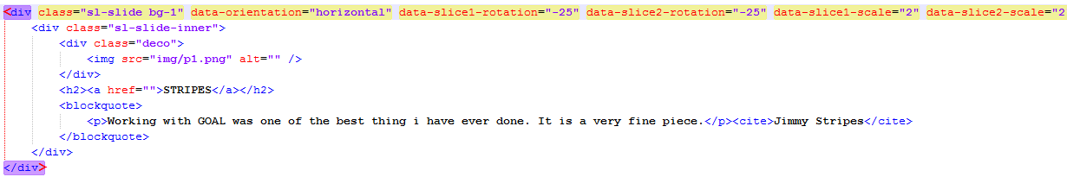

To edit the styles of this slider, please go to the *assets/slider/css/style.css* and *assets/slider/css/custom.css* files.

*Below the portfolio there is an element with a* ***window*** *class, which shows nothing except a transparent background in order to make a 3d effect.*

* 1. **Testimonials / Skills / Clients**
* The testimonials block is displayed using the orbit slider provided by zurb foundation (<http://foundation.zurb.com/docs/components/orbit.html>). Just add new elements and they will show up.
* The skills are displayed using the progress-bar provided by zurb foundation (<http://foundation.zurb.com/docs/components/progress_bars.html>)
* The clients are displayed using the CarouFredSel (<http://dev7studios.com/plugins/caroufredsel>)
  1. **Contact**

Ready2Go contact form, we set it up in the beginning of the tutorial, it also has a contact info widget which works as the testimonial block and a social media widget.

* 1. **Footer**

The footer only contains a background image in order to make some fancy effect under the portfolio section.

1. **Styles**

All styles are under the styles.css file located in the root folder. The portfolio styles are in the *assets/slider/css/style.css* and *assets/slider/css/custom.css* files.

1. **Scripts**

Each feature has its own js file in order to make it simpler to understand. Please go to assets folder and you will find multiple script files, very intuitive.

For more support, please email me at [cerdance@gmail.com](mailto:cerdance@gmail.com)

1. **Credits**

* Zurb Foundation (<http://foundation.zurb.com>)
* CarouFredSel (<http://dev7studios.com/plugins/caroufredsel>)
* EasyPieChart (<http://rendro.github.io/easy-pie-chart/>)
* SlitSlider (<http://tympanus.net/codrops/2012/06/05/fullscreen-slit-slider-with-jquery-and-css3/>)
* IcoMoon (<http://icomoon.io/>)

Thank you for purchasing GOAL.